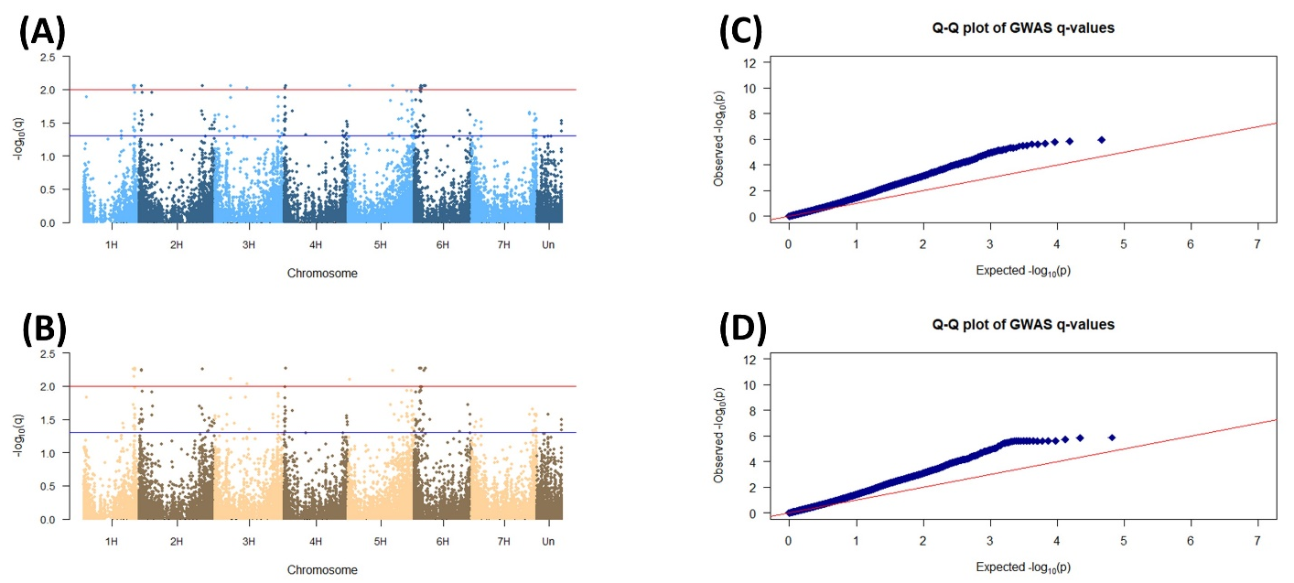
Figure S5. Manhattan plots and quantile–quantile (QQ) plot of coleoptile length. (A) The Manhattan plot of coleoptile length by GLM model using minor allele frequency (MAF)<0.05. (B) The Manhattan plot of coleoptile length by GLM model using minor allele frequency (MAF)<0.01. The results were presented using -log10 of FDR adjusted p values (q value) against position on each of the seven chromosomes. Horizontal dashed lines showed the genome wide significant threshold set at qFDR<0.05 (blue) and qFDR<0.05 (red). (C) QQ plot for coleoptile length based on -log10 of FDR adjusted p-values (q-value) by GLM model using MAF<0.05. (D) QQ plot for coleoptile length based on -log10 of FDR adjusted p-values (q-value) by GLM model using MAF<0.01

